CR-05 - Goals and Outcomes
Progress the jurisdiction has made in carrying out its strategic plan and its action plan. 91.520(a)
This could be an overview that includes major initiatives and highlights that were proposed and executed throughout the program year.

In accordance with 24 CFR 570, Cherokee County CDBG Office has prepared this Consolidated Annual Performance and Evaluation Report (CAPER) for the period of January 1, 2025, through December 31, 2025. The CAPER represents the County’s progress in carrying out projects and activities pursuant to the Program Year (PY) 2025 Annual Action Plan for the Community Development Block Grant (CDBG) and HOME Investment Partnerships (HOME) received from the United States Department of Housing and Urban Development (HUD) that benefits low- to-moderate-income persons who live in Cherokee County.
The 2025 CAPER describes and evaluates how Cherokee County invested formula funds from HUD to meet affordable housing and community development needs as contained in its Five-Year Consolidated Plan covering the period of January 1, 2024, through December 31, 2028. The 2025 CAPER and other planning documents may be accessed through the County’s website at www.cherokeecountyga.gov/cdbg.
Cherokee County continues to make progress with CDBG and HOME funds by increasing the supply of affordable, permanent housing, improving public infrastructure, increasing public services, public facilities, housing prevention, and home repairs for vulnerable households.
Comparison of the proposed versus actual outcomes for each outcome measure submitted with the consolidated plan and explain, if applicable, why progress was not made toward meeting goals and objectives. 91.520(g)
Categories, priority levels, funding sources and amounts, outcomes/objectives, goal outcome indicators, units of measure, targets, actual outcomes/outputs, and percentage completed for each of the grantee’s program year goals.

Goal | Category | Source / Amount | Indicator | Unit of Measure | Expected – Strategic Plan | Actual – Strategic Plan | Percent Complete | Expected – Program Year | Actual – Program Year | Percent Complete
Improve housing access and quality | Affordable Housing | CDBG: $ / HOME: $ | Homeowner Housing Added | Household Housing Unit | 10 | 0 | 0.00%
Improve housing access and quality | Affordable Housing | CDBG: $ / HOME: $ | Homeowner Housing Rehabilitated | Household Housing Unit | 25 | 0 | 0.00% | 6 | 3 | 50.00%
Improve housing access and quality | Affordable Housing | CDBG: $ / HOME: $ | Tenant-based rental assistance / Rapid Rehousing | Households Assisted | 50 | 0 | 0.00% | 20 | 17 | 85.00%
Improve public facilities, infrastructure, and com | Non-Housing Community Development | CDBG: $ | Public Facility or Infrastructure Activities other than Low/Moderate Income Housing Benefit | Persons Assisted | 1000 | 285 | 28.50% | 350 | 285 | 81.43%
Planning and administration | Program Administration | CDBG: $ / HOME: $ | Other | Other | 1 | 0 | 0.00%
Provide public services | Homeless  Non-Homeless Special Needs  Non-Housing Community Development | CDBG: $ | Public Facility or Infrastructure Activities other than Low/Moderate Income Housing Benefit | Persons Assisted | 0 | 187 |  | 1900 | 187 | 9.84%
Provide public services | Homeless  Non-Homeless Special Needs  Non-Housing Community Development | CDBG: $ | Public service activities other than Low/Moderate Income Housing Benefit | Persons Assisted | 8500 | 2233 | 26.27% | 0 | 2233
Provide public services | Homeless  Non-Homeless Special Needs  Non-Housing Community Development | CDBG: $ | Homeowner Housing Rehabilitated | Household Housing Unit | 0 | 3 |  | 0 | 3
Provide public services | Homeless  Non-Homeless Special Needs  Non-Housing Community Development | CDBG: $ | Homeless Person Overnight Shelter | Persons Assisted | 0 | 0 |  | 0 | 0
Table 1 - Accomplishments – Program Year & Strategic Plan to Date

Assess how the jurisdiction’s use of funds, particularly CDBG, addresses the priorities and specific objectives identified in the plan, giving special attention to the highest priority activities identified.
Cherokee County has seen an increase in demand for affordable housing, rental assistance, food, utilities, and minor home repairs for seniors. Community partners are also seeing an increase in assistance needed but funding has been decreased in some areas. Cost of living has increased over the past year along with rent. Cherokee allocates funds based on the priorities outlined int he Consolidated Plan 2024-2028 and PY 2025 Annual Action Plan. CDBG and HOME funds meet HUD's mandate and improve housing accessibility and affordability and quality of life for the LMI residents. (Cherokee also can not meet all of the public services needs requested).

CR-10 - Racial and Ethnic composition of families assisted
Describe the families assisted (including the racial and ethnic status of families assisted). 91.520(a)

 | CDBG | HOME
White | 3,123 | 0
Black or African American | 702 | 5
Asian | 67 | 0
American Indian or American Native | 17 | 0
Native Hawaiian or Other Pacific Islander | 0 | 0

Total | 3,909 | 5

Hispanic | 993 | 0
Not Hispanic | 2,916 | 5

Table 2 – Table of assistance to racial and ethnic populations by source of funds

Narrative
Cherokee County was able to assist 3909 residents in need with CDBG funds in PY 2025. This number is not the final count due to some projects still pending final reports and reimbursements.

CR-15 - Resources and Investments 91.520(a)
Identify the resources made available
Source of Funds | Source | Resources Made Available | Amount Expended During Program Year
CDBG | public - federal | 2,473,591 | 539,416
HOME | public - federal | 1,631,715 | 0
Table 3 - Resources Made Available

Narrative
Cherokee County was allocated $1,127,016.00 in CDBG funds for PY 2025 and $470,191.16 in HOME funds for PY 2025. The CDBG funds were made available in the fall of 2025 and subrecipient agreements were executed at that time. HOME funds were still being used from PY 2022 and therefore no applications were submitted.
CDBG funds in the amount of $169,052.40 was allocated for public services and $732,560.40 was allocated for public facility projects, all of which the agencies are located in and serving Cherokee County residents.

Identify the geographic distribution and location of investments
Target Area | Planned Percentage of Allocation | Actual Percentage of Allocation | Narrative Description
Countywide LMI persons/households | 100 |  | Projects serving persons meeting LMI criteria
Table 4 – Identify the geographic distribution and location of investments

Narrative
Two public facility projects were not completed at the time of this report. The projects are 95-98% completed and just waiting on final inspections and reimbursements. (Boys & Girls Club flooring and Bethesda Mobile Unit for Women's Health Care).
There is a balance of TBD funds in the amount of $167,563.40 that are available. Applications have been submitted and subrecipient agreements were executed March 3rd and March 17th for public facility projects. These projects are expected to be completed and reimbursed by May-June 2026.
Cherokee County CDBG office was not able to submit reports in a timely manner due to the government shutdowns and techinical issues that IDIS had. All issues have been resolved at this time and our office is back on track.
Leveraging
Explain how federal funds leveraged additional resources (private, state and local funds), including a description of how matching requirements were satisfied, as well as how any publicly owned land or property located within the jurisdiction that were used to address the needs identified in the plan.
Cherokee County receives CDBG and HOME funds from HUD and only HOME funds require a match of 25%. Prior to PY 2023, Cherokee County required subrecipients of CDBG funds to commit a portion of their resources for the proposed projects. Cherokee partners with MUST Ministries and Habitat for Humanity of North Georgia to distribute HOME funds. MUST Ministries administers the TBRA Program using HOME funds and Habitat serves as the county's CHDO, and uses the HOME funds for land acquisitions for affordable housing units/homes.
CDBG match funds are also determined on a case-by-case basis based on subrecipient's history, funding sources and monitoring audits and if they are new to CDBG.

Fiscal Year Summary – HOME Match
1. Excess match from prior Federal fiscal year | 0
2. Match contributed during current Federal fiscal year | 0
3. Total match available for current Federal fiscal year (Line 1 plus Line 2) | 0
4. Match liability for current Federal fiscal year | 0
5. Excess match carried over to next Federal fiscal year (Line 3 minus Line 4) | 0
Table 5 – Fiscal Year Summary - HOME Match Report

Match Contribution for the Federal Fiscal Year
Project No. or Other ID | Date of Contribution | Cash  (non-Federal sources) | Foregone Taxes, Fees, Charges | Appraised Land/Real Property | Required Infrastructure | Site Preparation, Construction Materials, Donated labor | Bond Financing | Total Match
Table 6 – Match Contribution for the Federal Fiscal Year

HOME MBE/WBE report
Program Income – Enter the program amounts for the reporting period
Balance on hand at begin-ning of reporting period  $ | Amount received during reporting period  $ | Total amount expended during reporting period  $ | Amount expended for TBRA  $ | Balance on hand at end of reporting period  $
0 | 0 | 0 | 0 | 0
Table 7 – Program Income

Minority Business Enterprises and Women Business Enterprises – Indicate the number and dollar value of contracts for HOME projects completed during the reporting period

 | Total | Minority Business Enterprises |  |  |  | White Non-Hispanic
 | Total | Alaskan Native or American Indian | Asian or Pacific Islander | Black Non-Hispanic | Hispanic | White Non-Hispanic

Contracts
Dollar Amount | 0 | 0 | 0 | 0 | 0 | 0
Number | 0 | 0 | 0 | 0 | 0 | 0

Sub-Contracts
Number | 0 | 0 | 0 | 0 | 0 | 0
Dollar Amount | 0 | 0 | 0 | 0 | 0 | 0

 | Total | Women Business Enterprises | Male

Contracts
Dollar Amount | 0 | 0 | 0
Number | 0 | 0 | 0

Sub-Contracts
Number | 0 | 0 | 0
Dollar Amount | 0 | 0 | 0
Table 8 - Minority Business and Women Business Enterprises

Minority Owners of Rental Property – Indicate the number of HOME assisted rental property owners and the total amount of HOME funds in these rental properties assisted

 | Total | Minority Property Owners |  |  |  | White Non-Hispanic
 | Total | Alaskan Native or American Indian | Asian or Pacific Islander | Black Non-Hispanic | Hispanic | White Non-Hispanic
Number | 0 | 0 | 0 | 0 | 0 | 0
Dollar Amount | 0 | 0 | 0 | 0 | 0 | 0
Table 9 – Minority Owners of Rental Property

Relocation and Real Property Acquisition – Indicate the number of persons displaced, the cost of relocation payments, the number of parcels acquired, and the cost of acquisition

Parcels Acquired | 0 | 0
Businesses Displaced | 0 | 0
Nonprofit Organizations Displaced | 0 | 0
Households Temporarily Relocated, not Displaced | 0 | 0

Households Displaced | Total | Minority Property Enterprises |  |  |  | White Non-Hispanic
Households Displaced | Total | Alaskan Native or American Indian | Asian or Pacific Islander | Black Non-Hispanic | Hispanic | White Non-Hispanic
Number | 0 | 0 | 0 | 0 | 0 | 0
Cost | 0 | 0 | 0 | 0 | 0 | 0
Table 10 – Relocation and Real Property Acquisition

CR-20 - Affordable Housing 91.520(b)
Evaluation of the jurisdiction's progress in providing affordable housing, including the number and types of families served, the number of extremely low-income, low-income, moderate-income, and middle-income persons served.

 | One-Year Goal | Actual
Number of Homeless households to be provided affordable housing units | 0 | 0
Number of Non-Homeless households to be provided affordable housing units | 0 | 0
Number of Special-Needs households to be provided affordable housing units | 2 | 0
Total | 2 | 0
Table 11 – Number of Households

 | One-Year Goal | Actual
Number of households supported through Rental Assistance | 0 | 0
Number of households supported through The Production of New Units | 0 | 0
Number of households supported through Rehab of Existing Units | 3 | 3
Number of households supported through Acquisition of Existing Units | 0 | 0
Total | 3 | 3
Table 12 – Number of Households Supported

Discuss the difference between goals and outcomes and problems encountered in meeting these goals.
Cherokee County CDBG supports Habitat for Humanity in their minor/emergency home repair program for seniors.
Discuss how these outcomes will impact future annual action plans.
Cherokee's future annual action plans will continue to include information on any program changes that are currently underway and determine the needs of its residents. The County will continue to support Habitat for land acquisions for the develop of affordable housing, as it is one of our greatest needs in the community with HOME funds along with MUST Ministries for the TBRA program.
The minor/emergency home repair program for seniors continues to inform funding decisions each program year in addressing affordable housing goals and eliminate substandard housing. Many of our seniors cannot afford to live in an assisted living facility and need assistance staying in their homes so that they can age in place safely.
Include the number of extremely low-income, low-income, and moderate-income persons served by each activity where information on income by family size is required to determine the eligibility of the activity.

Number of Households Served | CDBG Actual | HOME Actual
Extremely Low-income | 2 | 0
Low-income | 1 | 0
Moderate-income | 0 | 0
Total | 3 | 0
Table 13 – Number of Households Served

Narrative Information
N/A

CR-25 - Homeless and Other Special Needs 91.220(d, e); 91.320(d, e); 91.520(c)
Evaluate the jurisdiction’s progress in meeting its specific objectives for reducing and ending homelessness through:
Reaching out to homeless persons (especially unsheltered persons) and assessing their individual needs
MUST Ministries continues to be the County’s leading non-profit agency for assisting the homeless and near homeless populations. MUST Ministries also coordinates the volunteers and other non-profit agencies in the community to participate in the Point-in-Time counts. On January 26, 2026, representatives/volunteers from Cherokee County Homeless Veteran Program, American Legion Post 45, MUST Ministries, Cherokee County Homeless Coalition and many other agencies/volunteers participated in the PIT count. The results were over 500 homeless people are living in Cherokee County, the highest it has ever been. Over 40 of the 500 are veterans and living in tents throughout the county.
Cherokee County CDBG staff participates in monthly meetings hosted by Families of Cherokee United in Service (Cherokee FOCUS), Canton Housing Authority, Cherokee Regional Housing Forums, Chamber of Commerce and Cherokee County Triad-S.A.L.T. for seniors. These various meetings and organizations exchange of information, best practices, and critical, unaddressed or under-addressed needs in the community.
Addressing the emergency shelter and transitional housing needs of homeless persons
The County continues to provide CDBG and HOME funds to MUST Ministries’ Supportive Housing Program and TBRA Program. MUST Ministries also receives additional funding from the County besides CDBG and HOME funds. During the winter months, several faith-based organizations open up warming shelters, as Cherokee does not have an actual shelter available to residents. Local churches provide rental assistance when funding is available along with Cherokee County Homeless Coalition.
Serenade Heights is another subrecipient of CDBG funds and assists single mothers and their children by providing transitional housing and support. Cherokee Family Violence Center provides emergency shelter and transitional housing for women and their children who have experienced domestic violence but do not apply or receive any CDBG or HOME funds.
Helping low-income individuals and families avoid becoming homeless, especially extremely low-income individuals and families and those who are: likely to become homeless after being discharged from publicly funded institutions and systems of care (such as health care facilities, mental health facilities, foster care and other youth facilities, and corrections programs and institutions); and, receiving assistance from public or private agencies that address housing, health, social services, employment, education, or youth needs
One program that stands out in the community is Goshen Valley Boys Ranch. Goshen provides loving family environments to youth in foster care, along with family resources to help keep families together. They also have independent living and transitional housing for both males and females who choose to stay in the foster care system, after aging out at the age of 18. Goshen has established programs for youth aging out of the foster care system by providing assistance and guidance with work opportunities or furtherance of education/training. The County supports these programs with CDBG funds.
CDBG funds have been used to partially fund the salaries of case managers in MUST Ministries’ Supportive Housing Program that manages services to homeless and chronically homeless individuals afflicted with addiction, mental illness, physical disorders, or co-occurring disorders, any of which prevent independent living. The program helps to provide housing stability and support through medical services, assistance with mainstream benefits, and obtaining employment. Two other non-profit partners provide services to obtain stability: employment training through its Career Pathways Program (Goodwill of North Georgia) and low-cost/no cost healthcare services for the uninsured and underinsured persons of Cherokee County (Bethesda Community Clinic).
Helping homeless persons (especially chronically homeless individuals and families, families with children, veterans and their families, and unaccompanied youth) make the transition to permanent housing and independent living, including shortening the period of time that individuals and families experience homelessness, facilitating access for homeless individuals and families to affordable housing units, and preventing individuals and families who were recently homeless from becoming homeless again
N/A

CR-30 - Public Housing 91.220(h); 91.320(j)
Actions taken to address the needs of public housing
Cherokee County intends to utilize the CDBG PY 2025 funds and HOME PY 2022-2023 funds to address the need of public housing. Cherokee County public housing is provided through the Housing Authority of the City of Canton, an independent agency. The Housing Authority has three campuses with a total of 145 housing units. Several of these units/campuses have been renovated or demolished and new units have been built and additional housing units have been added as well.
HOME funds from PY 2022 were distributed to Habitat for Humanity of North GA to build 3 homes for 3 families in Canton GA. One home was completed in December of 2024 and the 2 additional homes were completed in 2025 and families have been placed in the homes.
Habitat for Humanity has remaining funds in HOME PY 2022-2025 for land acquision but there have been no further requests for funding.
Actions taken to encourage public housing residents to become more involved in management and participate in homeownership
The CDBG staff has been working with Habitat for Humanity to encourage PHA residents to participate in homeownership through application meetings. It is through these application workshops that residents of the housing authority units learn how to qualify for homeownership. In addition, the County’s AI process involves the CHA to encourage input from PHA residents by hosting a public meeting for comments and input for that regular assessment. The agency had previously been very troubled, but the wholesale change in the Board has shown promise and the agency is no longer troubled.
Actions taken to provide assistance to troubled PHAs
Cherokee County currently does not have troubled PHAs.

CR-35 - Other Actions 91.220(j)-(k); 91.320(i)-(j)
Actions taken to remove or ameliorate the negative effects of public policies that serve as barriers to affordable housing such as land use controls, tax policies affecting land, zoning ordinances, building codes, fees and charges, growth limitations, and policies affecting the return on residential investment. 91.220 (j); 91.320 (i)
The Goals and Objectives established in the 2024 Analysis of Impediments to Fair Housing Choice (AI) served an integral part in formulating the strategies, goals, and objectives of the program for the County’s Consolidated Plan (2024-2028) and the annual action plan for program year 2025.
The CDBG Program Office supports the recommendations to help increase the supply of affordable housing/workforce housing in the county.
Actions taken to address obstacles to meeting underserved needs. 91.220(k); 91.320(j)
Cherokee County's biggest obstacle in meeting its underserved is the limited resources and lack of affordable housing available to the community. The County continues to grow leaps and bound each year, making the LMI population in more need of services/resources. The CDBG Program Office makes every effort to be visible in the community and address the needs, but funding options are being cut and everyone is fighting for the same dollar. (Many of the non-profit organizations are experiencing reduced funding from other resources).
Actions taken to reduce lead-based paint hazards. 91.220(k); 91.320(j)
The County undertakes lead-based paint inspections on all rehab work of homes or facilities built prior to 1978. In the event that lead-based paint is detected, abatement is completed as part of the project.
Actions taken to reduce the number of poverty-level families. 91.220(k); 91.320(j)
The County works with local non-profits to address poverty reduction. The following are some actions taken by Cherokee County’s non-profit organizations:
- MUST Ministries provides stable rental housing for persons who are difficult to house with physical or mental disabilities, addictions, or co-occurring disorders in their supportive housing program; MUST Ministries also operates a food bank and summer lunch program in Cherokee County and is now administering HOME funds for TBRA;
- Cherokee Child Advocacy Council [Anna Crawford Children’s Center] provides child advocacy services and forensic interviews of victim children along with tailored therapeutic services to prevent the ongoing cycle of abuse in families;
- Goshen Valley Boys Ranch has programs in place to facilitate success for children aging out of the foster care system;
- The Boys & Girls Club – Mimms Club provides transportation for LMI youth for after-school and summer school programs. The club also provides a reading program for youth in grades 3-8 to improve literacy and build a firm foundation for success in high school. A third program offers teen mentoring to prepare students for success after high school;
- The Children’s Haven provides supervised visitation of children in the foster care system with nonoffending family as well as child advocacy services;
- Cherokee Family Violence Center provides transitional housing for victims of abuse as well as an emergency shelter for victims and their children of domestic abuse; the agency has not requested funding in the recent past from the County, but referrals are made to clients who inquire with the County;
- Warming shelters are provided by Action Church to address the needs of the homeless when the temperatures are very cold;
- Bethesda Community Clinic provides free and low cost health care to extremely low and low income persons in Cherokee County;
- The YMCA provides financial assistance to LMI youth and youth in the foster care system to participate in programming at a summer day camp; and
- The County maintains a Section 3 policy.
Cherokee County also receives HOME funds that allow Tenant Based Rental Assistance Program (TBRA) and land acquisitons to be awarded to Habitat for Humanity to construct affordable housing units.

Actions taken to develop institutional structure. 91.220(k); 91.320(j)
The CDBG staff works with all County departments to ensure compliance with HUD guidelines and County policies and how best to serve the needs of the LMI populations. With regard to community partners, the involvement of the CDBG Program Office in the Housing Collaborative and the FOCUS Collaborative allows the County to engage partners to further the mission of the CDBG Program. Non-profit agencies and participating cities provide input of unmet needs of the community at annual grant application workshops and assist in providing opportunities to leverage other sources of funding with CDBG funds to achieve program goals.
The County’s municipality partners include Canton, Ball Ground, Holly Springs, Nelson, Waleska, and Woodstock. These Cities are also participating cities as part of the County’s designation as an Urban County. The Cities have agreed to continue as participating cities for the Consolidated Plan and their agreements have automatic renewal properties. (The County gives the Cities the opportunity to withdraw at each renewal interval.)
Actions taken to enhance coordination between public and private housing and social service agencies. 91.220(k); 91.320(j)
Public housing and social service agencies are invited to the annual application workshops to provide a forum to gather information concerning unmet needs in the community. Agencies are also encouraged to share best practices in a setting that might include an agency new to the grant application process. Cherokee County non-profit organizations work together to coordinate services with each other.
Habitat for Humanity – North Central Georgia, through its experience and resources, administers the County’s Minor/Emergency Home Repair Program. In addition, Stand-Up for Seniors has partnered with Senior Services to obtain funding for home modifications and programs for assistance for veterans of the armed forces. The targeted population includes home-delivered meals clients.
CDBG funds have been used to partially fund the salaries of case managers in MUST Ministries’ Supportive Housing program that manages services to homeless and chronically homeless individuals afflicted with addiction, mental illness, physical disorders, or co-occurring disorders, any of which prevent independent living. The program helps provide housing stability and support through medical services, assistance with obtaining mainstream benefits, and assistance with finding gainful employment. Goodwill of North Georgia has a Career Pathways program where a partnership has been formed with Chattahoochee Tech to provide job training and support services for LMI persons seeking gainful employment.
Identify actions taken to overcome the effects of any impediments identified in the jurisdictions analysis of impediments to fair housing choice. 91.520(a)
Impediment: Availability of Affordable Housing Units. More than 13% of households, or 63% of family households, use more than 50% of their income for housing costs. Approximately three-fourths of the households in Cherokee County are family households.
Actions: The County's 2025 Action Plan provided funding for land acquisition for affordable housing development through the HOME Program. The Minor/Emergency Home Repair Program was continued for 2025 to allow seniors to age in place and prevent veterans and disabled persons from being uprooted.
Impediment: Lack of Affordable, Integrated Housing for Individuals Who Need Supportive Services. The County collected data in the 2024 AI that indicated that people have limited options for living independently with disabilities [new neighborhood developments offer ranch style homes rendering homes built to specifications very expensive; and rental housing that is deemed accessible really isn’t accessible].
Actions: The County provided an award to partially fund the salaries of case managers in MUST Ministries, Inc.’s Supportive Housing Program. MUST has rental units to provide stable housing for homeless, chronically homeless, and difficult to house persons who may be experiencing addictions, physical disabilities, or co-occurring issues. Case managers assist clients in obtaining mainstream benefits as well as other support services.
Stand-Up for Seniors of Cherokee County provides handicapped ramps and accessibility features to the homes of seniors referred through the County’s Senior Center. This program is self-funded through fundraising activities. Targeted clients include seniors who receive home-delivered meals. In addition, Habitat for Humanity has obtained funding for home modifications for persons with mobility issues or who are aging in place. The County supports Habitat for Humanity with grant funding to allow persons to age in place and to assist disabled persons in navigating the home better with the minor/emergency home repair program.
Impediment: Neighborhood Environment Impediments. Availability, type, frequency, and reliability of public transportation was noted as a non-priority contributing factor for all three areas of the fair housing analysis in the County’s AI: Segregation / Integration; Disparities in Access to Opportunities, and Disproportionate Housing Needs (there are no Racial or Ethnically Concentrated Areas of Poverty).
Actions: CDBG funds are being used to fund a transportation program offered by the Boys & Girls Club to transport youth to after school and summer programming designed to improve literacy and the success rate of high school graduates after high school. This service will supplement the transportation services offered by the County’s transportation system, which has limited routes and service hours and one fixed route. Park improvements in a low-mod areas have begun in Canton, including a new playground.

CR-40 - Monitoring 91.220 and 91.230
Describe the standards and procedures used to monitor activities carried out in furtherance of the plan and used to ensure long-term compliance with requirements of the programs involved, including minority business outreach and the comprehensive planning requirements

Cherokee County performs a yearly risk analysis and assessment for each grantee. Subrecipients are monitored to ensure they are in compliance with applicable laws and regualtions. The County evaluates and documents the eligibility of all grant-funded activities and monitors the staus of contracts. Monitoring is done on a monthly basis when subrecipients submit their monthly reimbursements and progress reports and any issues are addressed right then. Once the program year is closed and the subrecipient has received all of their funding, a final audit is conducted either in person or as a desk review. (Electronically)
Additionally, agencies receive technical assistance throughout the grant cycle and during the mandatory workshop. Cherokee County also performs sight visits and communication throughout the program year.

Citizen Participation Plan 91.105(d); 91.115(d)
Describe the efforts to provide citizens with reasonable notice and an opportunity to comment on performance reports.
Cherokee County CDBG Office staff advertises in the local county paper, on their website, hosts a public hearing and at local organization meetings that are attended. Citizens are given a minimum of 2 weeks to respond either in person, phone, email or mail.
The citizens can also attend the Board of Commissioner's meeting where the information is being presented and voted on. There is a public comment allowance during the meeting for citizens to voice any questions, concerns, etc.
The Public Comment period advertised in the Cherokee Tribune on March 24,2026 and expired on April 8, 2026. The public hearing was held on April 3, 2026, and no one attended. There were no inquiries via phone, email mail or in-person. The Cherokee County Board of Commissioners reviewed and approved submission of the CAPER April 7, 2026.

CR-45 - CDBG 91.520(c)
Specify the nature of, and reasons for, any changes in the jurisdiction’s program objectives and indications of how the jurisdiction would change its programs as a result of its experiences.
In 2025, there were no major changes to Cherokee County's CDBG or HOME objectives. The HOME Program continues to serve those in need of rental assistance through the TBRA Program and Habitat for Humanity of North Georgia serves as the CHDO for land acquisitions. (Cherokee County's HOME Program is still untilizing funds from PY2022 and PY 2023).
Cherokee County's CDBG funds continue to focus on public services and public facility improvements for local non-profit agencies that meet the national objectives.
Does this Jurisdiction have any open Brownfields Economic Development Initiative (BEDI) grants?
No
[BEDI grantees] Describe accomplishments and program outcomes during the last year.

CR-50 - HOME 24 CFR 91.520(d)
Include the results of on-site inspections of affordable rental housing assisted under the program to determine compliance with housing codes and other applicable regulations
Please list those projects that should have been inspected on-site this program year based upon the schedule in 24 CFR §92.504(d). Indicate which of these were inspected and a summary of issues that were detected during the inspection. For those that were not inspected, please indicate the reason and how you will remedy the situation.
Cherokee County CDBG office has an agreement with MUST Ministries, Inc., to administer the HOME-TBRA Program. MUST Ministries, Inc., provides case management of the program while HUD provides the funding for the rental of the units. Inspections are also conducted by MUST Ministries, Inc., and all federal regulations are followed by their agency.
Provide an assessment of the jurisdiction's affirmative marketing actions for HOME units. 24 CFR 91.520(e) and 24 CFR 92.351(a)
All affirmative marketing actions for the HOME-TBRA Program are submitted in the monthly reimbursement packets to the Cherokee County CDBG office.
Refer to IDIS reports to describe the amount and use of program income for projects, including the number of projects and owner and tenant characteristics
N/A
Describe other actions taken to foster and maintain affordable housing. 24 CFR 91.220(k) (STATES ONLY: Including the coordination of LIHTC with the development of affordable housing). 24 CFR 91.320(j)
N/A

CR-58 – Section 3
Identify the number of individuals assisted and the types of assistance provided

Total Labor Hours | CDBG | HOME | ESG | HOPWA | HTF
Total Number of Activities | 1 | 0 | 0 | 0 | 0
Total Labor Hours | 0
Total Section 3 Worker Hours | 0
Total Targeted Section 3 Worker Hours | 0
Table 14 – Total Labor Hours

Qualitative Efforts - Number of Activities by Program | CDBG | HOME | ESG | HOPWA | HTF
Outreach efforts to generate job applicants who are Public Housing Targeted Workers
Outreach efforts to generate job applicants who are Other Funding Targeted Workers.
Direct, on-the job training (including apprenticeships).
Indirect training such as arranging for, contracting for, or paying tuition for, off-site training.
Technical assistance to help Section 3 workers compete for jobs (e.g., resume assistance, coaching).
Outreach efforts to identify and secure bids from Section 3 business concerns.
Technical assistance to help Section 3 business concerns understand and bid on contracts.
Division of contracts into smaller jobs to facilitate participation by Section 3 business concerns.
Provided or connected residents with assistance in seeking employment including: drafting resumes,preparing for interviews, finding job opportunities, connecting residents to job placement services.
Held one or more job fairs.
Provided or connected residents with supportive services that can provide direct services or referrals.
Provided or connected residents with supportive services that provide one or more of the following: work readiness health screenings, interview clothing, uniforms, test fees, transportation.
Assisted residents with finding child care.
Assisted residents to apply for, or attend community college or a four year educational institution.
Assisted residents to apply for, or attend vocational/technical training.
Assisted residents to obtain financial literacy training and/or coaching.
Bonding assistance, guaranties, or other efforts to support viable bids from Section 3 business concerns.
Provided or connected residents with training on computer use or online technologies.
Promoting the use of a business registry designed to create opportunities for disadvantaged and small businesses.
Outreach, engagement, or referrals with the state one-stop system, as designed in Section 121(e)(2) of the Workforce Innovation and Opportunity Act.
Other.
Table 15 – Qualitative Efforts - Number of Activities by Program

Narrative
Section 3 was not applicable in PY 2025 CDBG/HOME programs or projects. Goodwill of North Georgia is a subrecipient of CDBG funds and utilizes the funds for their Career Pathways Program that collaborates with a local technical school to provide training and support services for certifications such as Forklift Operator, Medical Billing/Coding, etc. Goodwill also conducts job fairs as part of their recruiting efforts to attract participants. MUST Ministries, Serenade Heights, and Circle of Friends also offer GED services, resume writing, interview preparation, job searches and interview clothing.

CR-60 - ESG 91.520(g) (ESG Recipients only)
ESG Supplement to the CAPER in e-snaps
For Paperwork Reduction Act
1. Recipient Information—All Recipients Complete
Basic Grant Information
Recipient Name | CHEROKEE COUNTY

Organizational DUNS Number | 101493158

UEI

EIN/TIN Number | 586000799

Indentify the Field Office | ATLANTA

Identify CoC(s) in which the recipient or subrecipient(s) will provide ESG assistance

ESG Contact Name
Prefix

First Name

Middle Name

Last Name

Suffix

Title

ESG Contact Address
Street Address 1

Street Address 2

City

State

ZIP Code | -

Phone Number

Extension

Fax Number

Email Address

ESG Secondary Contact
Prefix

First Name

Last Name

Suffix

Title

Phone Number

Extension

Email Address

2. Reporting Period—All Recipients Complete
Program Year Start Date | 01/01/2025

Program Year End Date | 12/31/2025

3a. Subrecipient Form – Complete one form for each subrecipient
Subrecipient or Contractor Name
City
State
Zip Code
DUNS Number
UEI
Is subrecipient a vistim services provider
Subrecipient Organization Type
ESG Subgrant or Contract Award Amount

Attachment
Cherokee PR-26
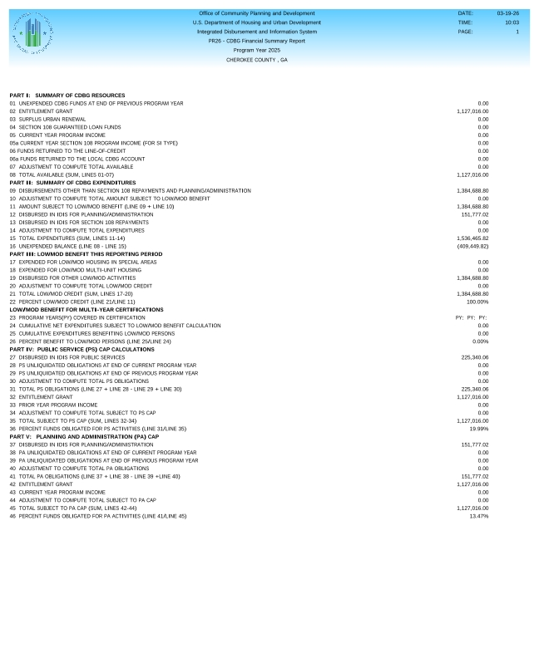
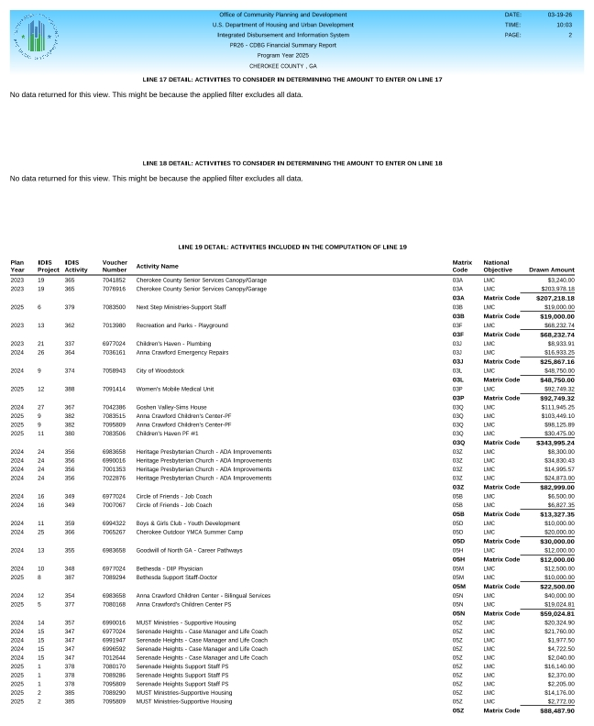
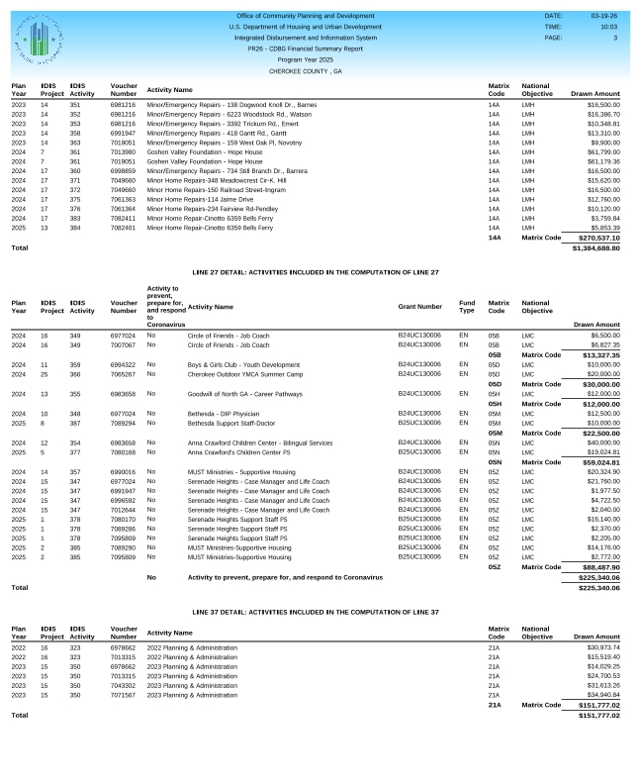

Public Comment
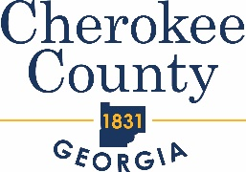 Friday, April 3, 2026
10:30 AM

Community Development Block Grant (CDBG) and HOME Program
Public Comment Meeting for Program Year 2025 Consolidated Annual Performance Evaluation Report (CAPER)

AGENDA

- Welcome & Introduction

- Purpose of Meeting

- PY 2025 Consolidated

- Questions

- Adjournment

Cherokee PR-23 CDBG
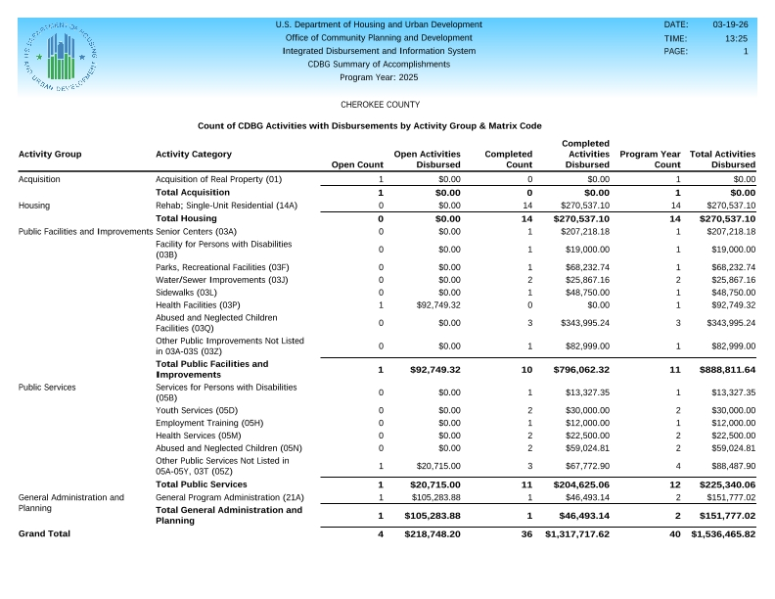
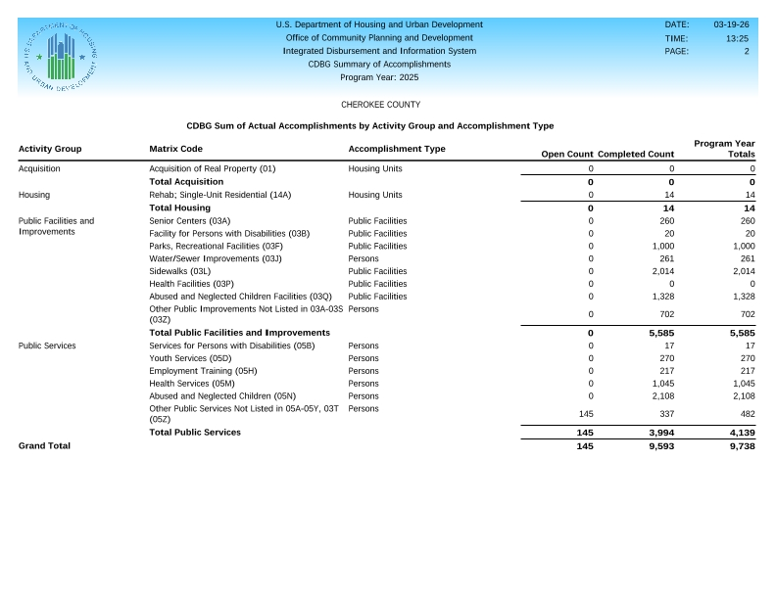
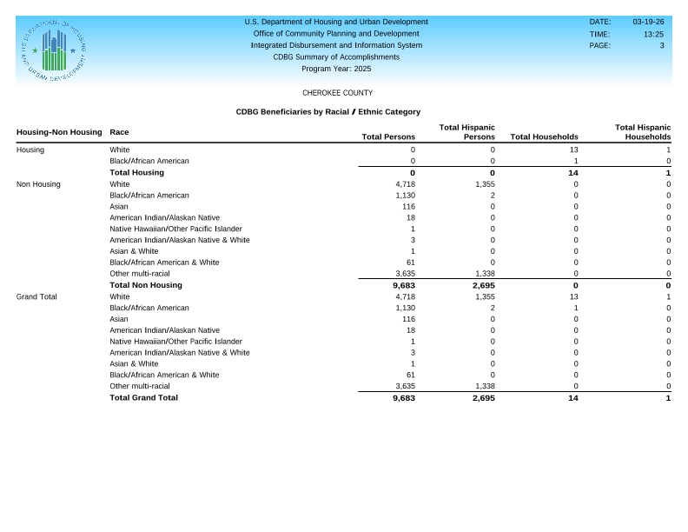
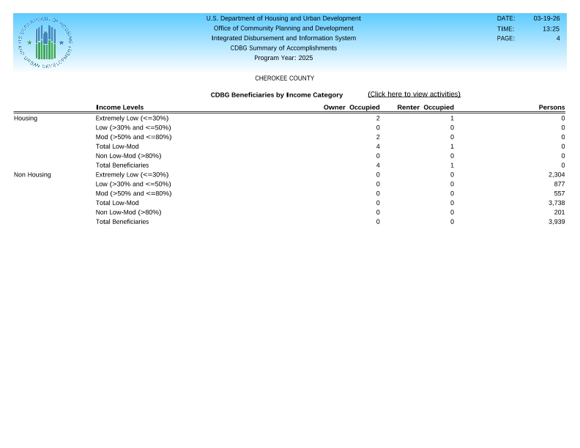

Cherokee PR-23 HOME
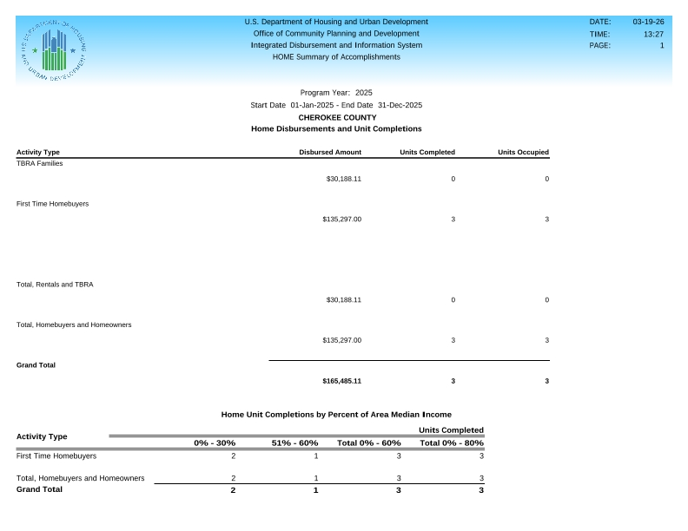
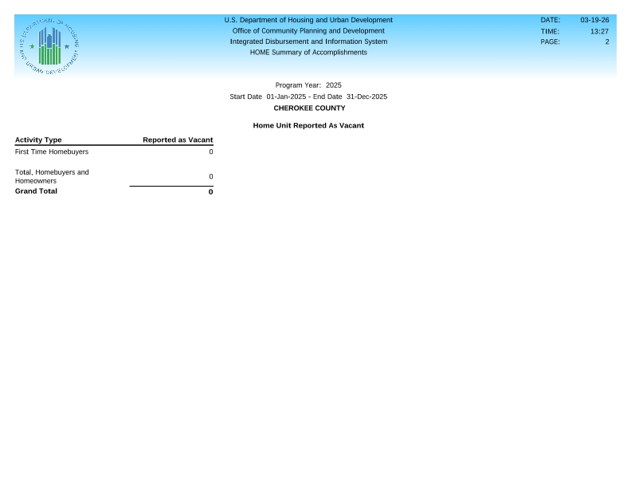
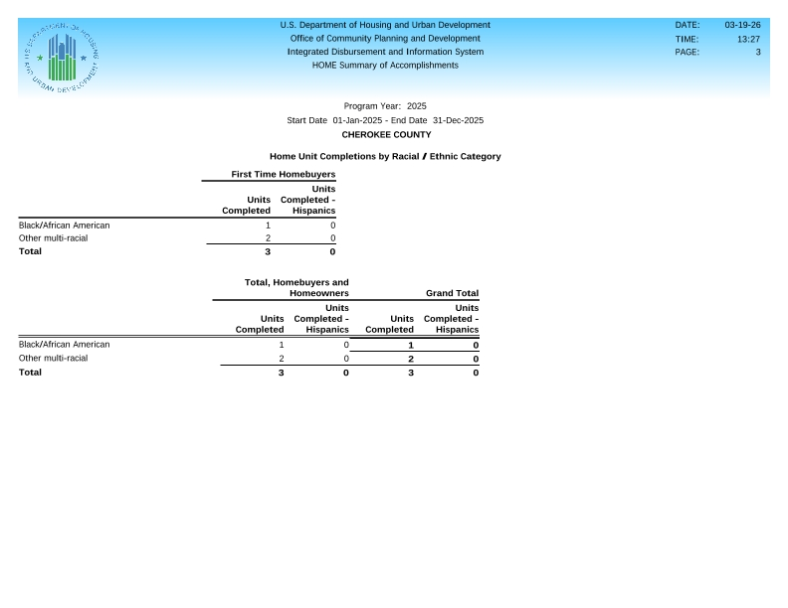

Cherokee Tribune Ad
